Introduction to AI COM727 Software Prototype and with Technical Report (AE2)
Your student number + Name:
Your team member’s name if applicable
(for the implementation of the prototype)

Table of Contents
Introduction 2
Need for your prototype 2
Statement of the problem. 2
Aims and Objectives 3
Prototype Development and AI Algorithms used 5
Requirements 5
Modules. 5
Implementation. 5
AI Algorithms Involved. 8
Conclusion 10
Reference List. 11

Introduction
The Artificial Intelligence (AI) has progressively crept into every bit of our life, providing game-changing solutions in fields like medicine, education, and communication. One of the very first studies within the field was held by a British mathematician, Alan Turing, in 1950. He proposed that machines could imitate human behaviour while performing cognitive tasks, which later came to be known as the Turing Test. This concept laid the foundation for further AI development, including chatbots. Chatbots, based on natural language processing, are those systems that simulate human interaction in real time to assist or support the user (Shawar and Atwell, 2007).

AI systems, particularly chatbots, have become incredibly useful in various fields, such as mental health, because they provide users immediate assistance and resources. While these are the benefits, on the other side, there exist immense legal, social, ethical, and professional challenges. For sensitive data, legal matters related to data protection are considered, for instance. Ethics in accuracy deal with ensuring the AI understands emotions and guarantees impartial responses. Professionally, the chatbots are set not to replace human professionals but only to add tools that will help a user navigate emotional distress while being under human oversight and judgment.

This paper will consider the design and deployment of CareBot: a chatbot featuring AI for mental health support that includes user interaction, assessment of emotional states, and guidance toward appropriate resources. The ethical and legal concerns, particularly those that relate to data privacy and inclusivity, are considered in making the development of CareBot reliable and safe to use within low-risk parameters. The report also quotes the challenges during development and enhances the recommendations for future iterations.

Need for your prototype
CareBot is developed to provide users with a conversational chatbot that can interact and respond empathetically to their mental health concerns. The incorporation of sentiment analysis, NLP, and entity extraction helps the system give appropriate responses related to user input, which include emotional support mixed with practical resources. It fills a significant gap in real-time, personalized interaction for the management of mental health without the need for immediate human intervention.

Statement of the problem.
As mental health awareness expands, the demand for support services frequently outpaces the available human resources, resulting in excessive wait periods and insufficient timely assistance, particularly during crises. Stigma, fear of judgment, and a lack of understanding about available resources all serve as deterrents to getting help, worsening the situation. To overcome these issues, novel solutions are required that provide easy access, confidentiality, and real-time support. Such solutions could eliminate stigma by providing anonymous support while also assisting in crisis prevention through instant treatment. Integrating these innovative approaches into existing services can increase general accessibility and lead to improved community mental health.

Aims and Objectives

- To create a chatbot prototype that provides emotional support depending on user feedback using sentiment analysis.
- To assist people in managing their emotions and mental health by providing relevant information and recommending professional help when needed.
- To imitate an empathetic discussion so that people feel heard and supported.
- To create a safe environment in which users can communicate anonymously about their emotional states.
- To continuously learn and develop through user interactions by adding machine learning techniques, the chatbot can fine-tune its responses over time and provide more tailored emotional support.
- To secure user privacy and data security, utilize strong encryption methods and stringent privacy policies to protect sensitive user information while maintaining trust and confidentiality during interactions.

Proposed Solution
CareBot is an AI-powered chatbot that analyses user sentiment, recognizes emotional cues, and offers relevant responses and resources. In addition to providing sympathetic assistance, CareBot allows users to make appointments with mental health doctors and access online resources suited to their emotional needs. CareBot uses sentiment analysis and natural language processing (NLP) to monitor and classify feelings as positive, negative, or neutral. It then reacts with helpful messages or connects users to relevant mental health resources, such as articles, exercises, or professional services.

Prototype Design
Several studies have explored the development of AI chatbots in mental health and education, demonstrating both the potential and limitations of such systems. D’Alfonso (2020) highlighted the increasing role of AI in mental health care, noting its ability to provide scalable support for users experiencing emotional distress. Similarly, Chen, Szolovits, and Ghassemi (2019) discussed how AI could help reduce disparities in healthcare, particularly in mental health by providing early intervention and access to resources for underserved populations.
In line with these findings, the CareBot prototype is designed to offer mental health support by providing users with empathetic responses and access to helpful resources. Inspired by these studies, the design of CareBot incorporates advancements in sentiment analysis and natural language processing (NLP) to respond to users' emotional states effectively.
However, a review of existing chatbot prototypes revealed gaps in prior implementations. For example, Lalwani et al. (2018) created an AIML-based chatbot for college-related queries but lacked advanced interaction capabilities. Similarly, Bavishi (2019) explored chatbots using Microsoft Azure to handle student queries but only supported basic text communication.
Building on these insights, CareBot integrates text-based interactions to provide accessible and effective mental health support. The inclusion of sentiment analysis using the TextBlob library allows the chatbot to evaluate emotional tone, while Spacy's NLP model ensures accurate extraction of key entities. The chatbot’s functionality extends beyond basic conversation, offering access to curated mental health resources and allowing users to schedule appointments with counselors.

Prototype Development and AI Algorithms used

Requirements
The following software, libraries and tools were used in the development of the CareBot prototype:
- Visual studio code: An integrated development environment (IDE) used for writing and debugging Python code, integrated with the Python environment for smooth development.
- Flask: A micro-web framework for creating web apps and managing chatbot queries.
The database is managed with Flask-SQLAlchemy, an Object Relational Mapper that makes working with MySQL simple.
- TextBlob: To ascertain the emotional tone of user input, sentiment analysis is carried out using this library.
- Spacy: An effective natural language processing (NLP) library for obtaining named entities (e.g., names, locations) from user input.
- PyMySQL: A Python client for MySQL that manages the connection between the MySQL database and Flask.
- MySQL: A relational database system for keeping track of appointments, logs, and user interactions.

Modules.
The CareBot system consists of three core modules:

app_logic.py
Handles all core functionalities of the chatbot, including sentiment analysis, entity extraction, logging user interactions, and scheduling appointments.

cli.py
Provides a command-line interface for interacting with the chatbot. Users can check in, view resources, or schedule appointments via text-based input.

models.py
Defines the database models for logging interactions, storing user data, and managing appointments.

Implementation.
The chatbot was implemented as follows:
- Sentiment Analysis: TextBlob’s Naive Bayes sentiment classification model is used to classify user input as positive, neutral, or negative. The chatbot uses the sentiment score to generate empathetic responses.

- Entity Extraction: Spacy is used to extract key entities from user input, which is essential for providing more personalized responses and suggestions.

- Logging and Database Interaction: SQLAlchemy manages database interactions, logging all user inputs and chatbot responses in a MySQL database for future reference.
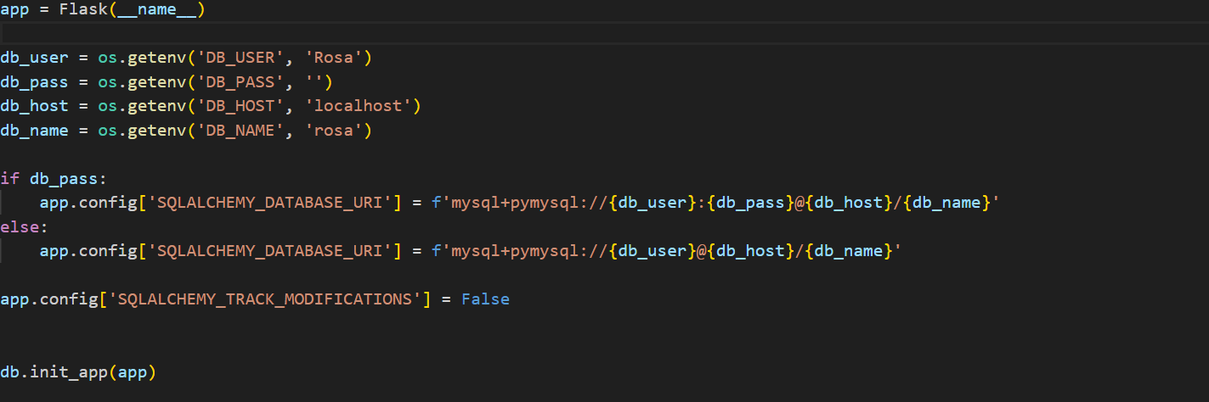
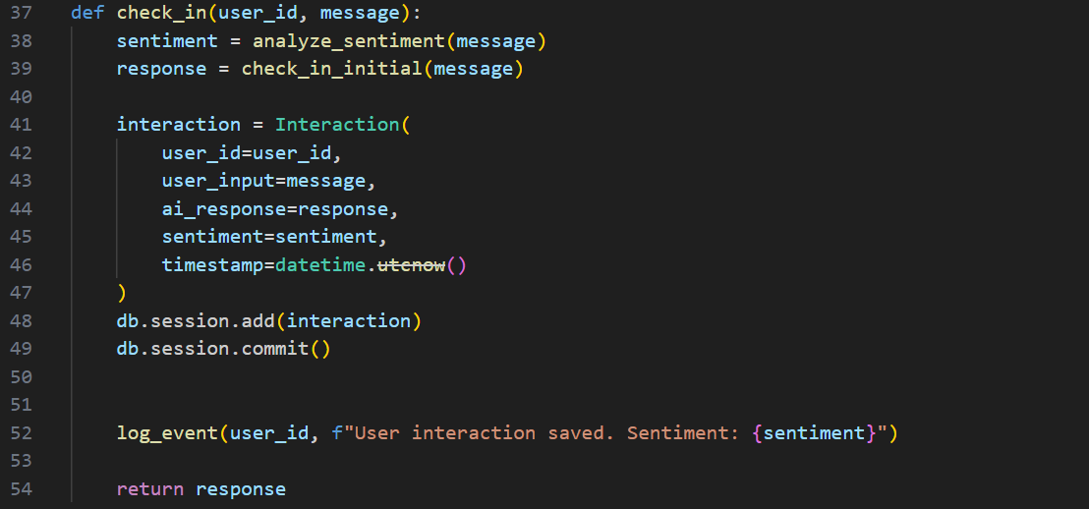
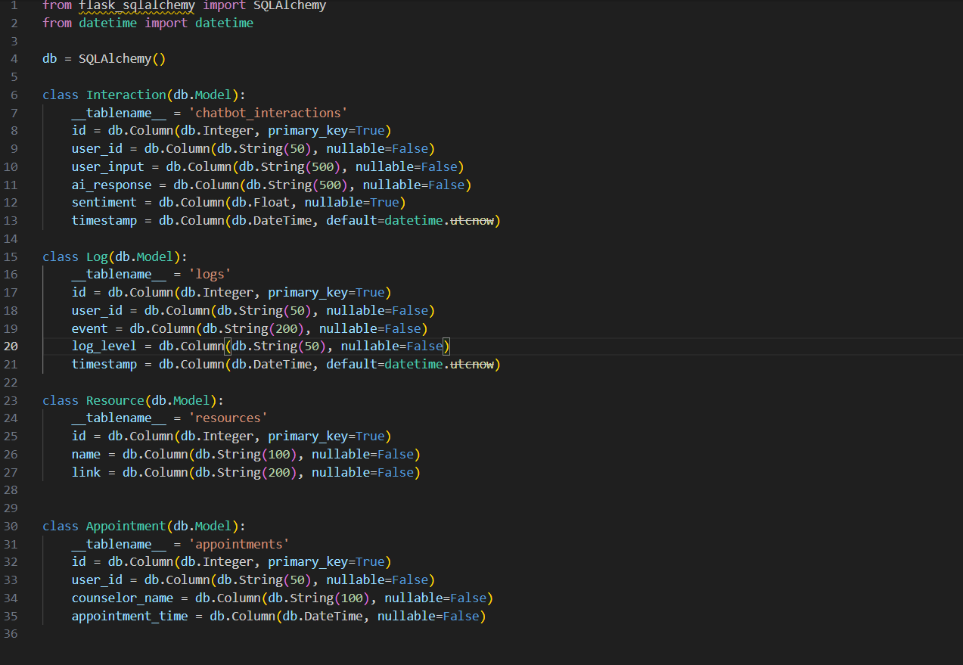

AI Algorithms Involved.

- Sentiment Analysis: The TextBlob sentiment analyzer is used to classify user input. Although TextBlob provides quick and lightweight sentiment detection, future versions could explore more advanced models like BERT for better accuracy in detecting nuanced emotions.
- Natural Language Processing (NLP): Spacy’s en_core_web_sm model is used for Named Entity Recognition (NER) to identify key information from user input, such as locations or names.
- Database Management: SQLAlchemy facilitates logging of user interactions and storing critical information, including appointments and counsellor details.

Steps for running the chatbot:
- Ensure that all dependencies are installed using pip install -r requirements.txt.
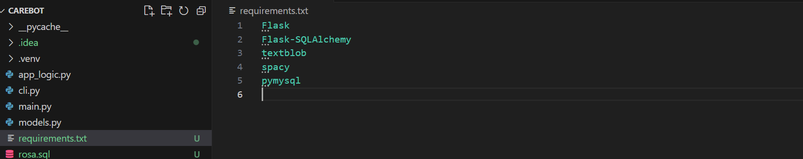
- Set up the MySQL database which you can host using a local XAMPP server. Update the environment variables with the database credentials from your XAMPP setup to connect to the chatbot.
- Run the Flask application with python main.py.
- The chatbot will prompt users to enter their emotional state, and all interactions will be recorded in the database.

Evaluation.
Several criteria were used to evaluate the CareBot prototype:
- Effectiveness: Based on user input, the chatbot was successful at accessing mental health resources, booking appointments, and conducting sentiment analysis. TextBlob's sentiment analysis was applied appropriately to both positive and negative inputs.

- Usability: The straightforward CLI-based interaction was simple to understand and follow. Options like "Check-in," "View Resources," and "Schedule Appointment" are simple for the user to find and use.

- Reliability: The chatbot managed database transactions and appropriate logging in a variety of scenarios without crashing. Typical exceptions were compassionately handled, like database disconnections or incorrect user input.

- Efficiency: The chatbot answered questions quickly and without needless pauses. Concise and uncomplicated information delivery improved the user experience by lowering complexity.

Limitations.
Designing the CareBot chatbot presented several challenges and limits, including:
- Managing Ambiguous User Input: It may be difficult for the chatbot to accurately understand ambiguous input, such as "I do not feel like am okay."
- Absence of Empathy in Responses: AI chatbots may not have the necessary emotional intelligence, which makes interactions seem artificial or predetermined.
- Managing Private Information and Sensitive Data: Since mental health chatbots handle sensitive information, privacy and legal compliance are issues.
- NLP Limitations: The named entity recognition model occasionally misclassified words, particularly when dealing with emotional contexts.
- Sentiment Accuracy: TextBlob sentiment analysis might be overly simplistic, failing to grasp the emotional complexity of complicated texts.
- Resource Constraints: The chatbot uses a static list of resources and does not dynamically retrieve updated materials from the web.
- Database Dependency: The chatbot requires a functional MySQL database; failure to properly configure the database may result in system failure.

Conclusion
The developed prototype Carebot demonstrated an effective ability to reply effectively to a very wide variety of inputs during its test with simulated user interactions, from highly negative remarks like 'I am feeling terrible' to positive ones like 'I am feeling terrific.' It can also store any conversations with a user in a database and retrieve mental health resources as needed.
The chatbot appears to have met the design objectives; nevertheless, there are several changes that might be made to maximise its potential. Improvements could lead to more neutral input handling for improved performance and user experience.

Reference List.
- D’ALFONSO, S., 2020. AI in mental health. Current Opinion in Psychology, 36, 112–117
- CHEN, I.Y., P. SZOLOVITS and M. GHASSEMI, 2019. Can AI Help Reduce Disparities in General Medical and Mental Health Care? The AMA Journal of Ethic, 21(2), E167-179
- GRAHAM, S. et al., 2019. Artificial Intelligence for Mental Health and Mental Illnesses: an Overview. Current Psychiatry Reports, 21(11)

